UNIVERSITY OF TEXAS AT EL PASO
ENVIRONMENTAL SCIENCE AND ENGINEERING PROGRAM

Investigating the Role of Differentially Expressed miRNAs in Colorectal Cancer with Insights into the Hispanic Population
Dissertation Proposal
Sheikh Shafin Ahmad

Sourav Roy, Ph.D., Chair
Manuel Miranda-Arango, Ph.D.
Renato J. Aguilera, Ph.D.
Taslim A. Al-Hilal, Ph.D.

Specific aims: This project aims to investigate the role of microRNAs (miRNAs) in Colorectal Cancer (CRC) tissues by identifying differentially expressed miRNAs between CRC and Normal Adjacent to Tumor (NAT) tissues in Hispanic and Non-Hispanic White (NHW) patients. The objective is to uncover miRNA signatures that are not only involved in CRC progression but also reflect ethnicity-specific molecular differences that may contribute to disparities in diagnosis and outcomes.
miRNAs are small non-coding RNAs that regulate gene expression post-transcriptionally, typically by binding to mRNA targets, thereby either promoting mRNA degradation or inhibiting their translation. Studies have found that their dysregulation can contribute to cancer development by affecting pathways involved in cell proliferation, apoptosis, and metastasis. In this study, we aim to identify key miRNAs associated with CRC and explore their downstream effects by integrating mRNA target prediction and pathway analyses. We hypothesize that CRC tissues exhibit distinct miRNA signatures, some of which vary between ethnic groups and may drive differences in tumor biology by targeting specific and critical mRNAs.
Specific Aim 1: To identify and characterize the differentially expressed miRNAs in CRC tissues compared to NAT tissues
Aim 1a: Identifying the differentially expressed miRNAs in CRC from transcriptomic data using computational analysis: RNA-sequencing reads from commercially sourced CRC tissues and NAT tissues will be aligned to the human reference genome and summarized as per-miRNA read counts. These counts will be normalized for library size within DESeq2, and subsequent differential expression testing would identify a high-confidence set of miRNAs differentially expressed between tumor and normal samples. Aim 1b: Predicting the mRNA targets of CRC associated miRNAs using integrative prediction tools: Target prediction using independent tools like TargetScan, miRDB, and miRTarBase will be used to predict and confirm mRNA targets of selected miRNAs. The predicted miRNA–mRNA interactions will be filtered based on inverse expression patterns identified in our list of differentially expressed genes (DEGs) and cross-checked against a list of genes confirmed to be associated with CRC, curated from various literature. mRNA targets meeting all these criteria will form a high-confidence miRNA–mRNA network for pathway analysis and subsequent experimental validation.
Specific Aim 2: To investigate the regulation of differentially expressed miRNAs in CRC tissues among Hispanic (H-CRC) and Non-Hispanic White (NHW-CRC) patients
Aim 2a: Identifying the differentially expressed miRNAs between H-CRC and NHW-CRC samples using computations analysis: RNA-sequencing data from tumor tissues, stratified by Hispanic and NHW groups, will be processed through the same alignment, counting and DESeq2 pipeline as described in Aim 1a. Differential expression testing will then pinpoint miRNAs that are significantly up- or down-regulated in one ethnicity relative to the other, producing ethnicity-specific miRNA signatures. Aim 2b: Predicting the mRNA targets of differentially expressed miRNAs between H-CRC and NHW-CRC using integrative prediction tools: For each miRNA identified that are significantly differentially regulated between H-CRC and NHW-CRC tissue samples, mRNA target prediction will be performed using TargetScan, miRDB, and miRTarBase, as described in Aim 1b. The predicted miRNA–mRNA interactions will be filtered by inverse expression patterns and further shortlisted based on supporting evidence from literature. The high-confidence miRNA targets will also undergo pathway analysis. This comparative analysis will identify miRNAs and their mRNA targets that are differentially regulated in CRC as well as those uniquely modulated in the Hispanic and NWH populations.
Specific Aim 3: To experimentally validate key miRNA-mRNA interactions with their specific targets and evaluating their role in the prognosis of CRC in cells
Aim 3a: Validating the effect of miRNA upregulation on target mRNA suppression: Colorectal-cancer cell lines will be transfected with synthetic miRNA mimics to raise intracellular levels of each candidate miRNA. Target gene mRNA levels will be quantified by qRT-PCR, and corresponding protein levels will be checked by Western blotting. A significant decrease in the target mRNA and protein levels will confirm post-transcriptional repression by the overexpressed miRNA. Aim 3b: Validating the effect of miRNA downregulation on target mRNA activation: To inhibit the same miRNAs, parallel cultures will be treated with antagomirs. Following miRNA inhibition, qRT-PCR analysis will determine whether the previously repressed target mRNAs show increased expression levels. Western blotting will similarly confirm changes in the corresponding protein expression. Aim 3c: Evaluating the impact of miRNA-mRNA mediated regulation on CRC cell proliferation: We will determine how the identified miRNA–mRNA target interactions affect the cancer cell growth by using CCK-8 proliferation assays. To ensure that the observed changes in cell proliferation are specifically mediated through the miRNA–mRNA interactions, we will perform rescue assays by restoring the target mRNAs into cells that were previously treated with antagomirs.
A. Background
Colorectal cancer (CRC) is among the deadliest forms of cancer worldwide. According to the SEER database, CRC was the fourth most diagnosed cancer in the United States in 2024, with 152,810 new cases (7.6% of all cancer diagnoses), and it caused 53,010 deaths (8.7% of all cancer deaths)¹. Disparities by race and ethnicity are evident, as Hispanic males and females had incidence rates of 39.4 and 28.7 per 100,000, respectively, while Non-Hispanic White males and females had slightly higher rates (42.0 and 32.4 per 100,000). Mortality rates also vary as Hispanic men and women had lower death rates (13.4 and 8.5 per 100,000) compared to Non-Hispanic Whites (15.2 and 10.9 per 100,000). These differences underscore the importance of tailoring CRC screening and treatment strategies to specific demographic groups to improve outcomes and reduce disparities¹. The prognosis of CRC has traditionally been assessed based on tumor size, metastatic spread, and surgical margin status². However, these clinical parameters alone are insufficient for accurately predicting patient outcomes. Current screening methods, including colonoscopy and fecal occult blood tests, have limitations due to their invasiveness, cost, and suboptimal sensitivity. Consequently, there is an increasing need for non-invasive, reliable biomarkers for early detection and prognosis. According to the American Cancer Society³, the 5-year relative survival rate for CRC is 63%. If diagnosed at an early stage (Stage I or II), the survival rate comes to about 91%. Once the cancer has spread to nearby tissues or regional lymph nodes, that rate drops to 72%. If the cancer has reached distant organs (Stage III or IV), the 5-year survival rate significantly falls to roughly 13%. This highlights the urgent need for early prognosis, especially in socioeconomically and medically marginalized populations such as Hispanics, who often face lower screening rates, delayed diagnoses, and poorer outcomes compared to NHWs⁴. Early detection and prevention of CRC also remain challenging. Recent studies show that Hispanic individuals are more likely to be diagnosed at advanced stages (Stage III/IV), with 32% of cases compared to 19% among NHWs⁵. Early-onset CRC (diagnosed before the age of 50) is more prevalent in Hispanics (56%) than in NHWs (35%)⁶. Timely diagnosis is also less frequent among Hispanic patients, with only 33% receiving it on time, compared to 35% in NHWs. Screening adherence is similarly lower, with just 49% of Hispanics following recommended screening protocols, while 58% of NHWs do⁷.
In recent years, microRNAs (miRNAs) have emerged as promising candidates in this area. These small non-coding RNA molecules (typically ~21–22 nucleotides in length) play a major role in regulating gene expression at the post-transcriptional level⁸. They can bind to complementary sequences in messenger RNAs (mRNAs), leading to either degradation of the mRNA or translational repression. Because of this regulatory capability, miRNAs influence a wide range of biological processes, including those directly tied to cancer such as cell cycle progression, apoptosis, angiogenesis, and metastasis⁹. Studies have shown that specific miRNAs can contribute to tumor initiation and progression in CRC, acting either as oncogenes or tumor suppressors.
Despite significant progress in miRNA research, several important gaps remain. Many studies have focused on only a small subset of miRNAs, leaving a large number of potentially relevant molecules unexplored. Additionally, although thousands of miRNA–mRNA interactions have been computationally predicted, only a fraction of these interactions have been experimentally validated using techniques like luciferase reporter assays, Western blotting, or quantitative real-time PCR (qRT-PCR). Without validation, the true biological impact of these predicted interactions is uncertain. Moreover, patient specific factors, particularly genetic and epigenetic differences across ethnic groups can influence miRNA expression levels. Emerging research suggests that miRNA expression profiles are not universal and generalized miRNA biomarkers may not perform equally well across all populations. For example, Hispanic and NHW patients may exhibit distinct patterns of miRNA regulation and tumor behavior, which could impact diagnosis and treatment outcomes.
Recent advancements in computational biology, along with large scale CRC datasets from consortia like The Cancer Genome Atlas (TCGA), have enabled more comprehensive analyses of miRNA-mRNA interactions¹⁰. Modern prediction algorithms, combined with pathway enrichment and network analysis tools, allow researchers to explore the downstream effects of miRNA dysregulation at the pathway level. In this study, we plan to integrate both computational and experimental methods to identify key miRNAs and their differentially expressed mRNA targets in CRC. A primary focus is to examine miRNA expression differences between Hispanic and NHW CRC patients, aiming to identify ethnicity-specific miRNA signatures that may influence disease progression and therapy response.

A1. Significance
This proposal aims to identify miRNAs that regulate gene expression in CRC across diverse populations, with a particular focus on underrepresented minority groups. Traditional methods for CRC prognosis, such as tumor size assessment, metastatic spread, and resection margin status, are invasive and have limited predictive value. These clinical approaches, combined with financial, cultural, and systemic barriers, have contributed to the exclusion of many underserved populations, including Hispanics, from early screening and timely intervention. Recent studies show that miRNA dysregulation is involved in several cancer hallmarks, including tumor proliferation, apoptosis, angiogenesis, and metastasis. However, many miRNAs remain insufficiently studied in the context of CRC, especially in ethnically diverse populations. Furthermore, most miRNA research to date lacks adequate clinical validation, limiting its translational potential as a source of diagnostic biomarkers or therapeutic targets. Our project seeks to address these gaps by characterizing the miRNA expression landscape in CRC tissues from both Hispanic and NHW patients. By identifying differentially expressed miRNAs and investigating their regulatory roles, we aim to uncover clinically relevant, ethnicity-specific biomarkers that could improve early detection and treatment stratification, ultimately reducing disparities in CRC outcomes.
B. Innovation
This proposal presents an innovative approach to understanding ethnic disparities in CRC by integrating miRNA regulation with transcriptomic and functional analyses across two distinct populations: Hispanic and NHW. While miRNAs have been widely implicated in CRC progression, few studies have explored how these small regulatory RNAs function in the context of population-specific gene regulation. Our proposal addresses this critical gap by stratifying transcriptomic data based on ethnicity, enabling the identification of novel, race-associated differentially expressed miRNAs and their downstream targets. By integrating multi-level experimental validation of miRNA–mRNA regulatory interactions, this project moves beyond in silico predictions, combining transcriptomic, proteomic, and phenotypic assays to validate the functional impact of candidate miRNA–target pairs. Furthermore, the emphasis on cross-ethnic comparison and functional testing are directly connected to health disparity contexts. This research will generate data with translational potential, laying the groundwork for ethnicity-informed diagnostic or therapeutic strategies by bridging population genetics, molecular biology, and functional genomics.
C. Research strategy
C1. Specific Aim 1: To identify and characterize the differentially expressed miRNAs in CRC compared to NAT tissues
C1.1 Preliminary data: In our preliminary investigation, we analyzed commercially sourced CRC and NAT tissues to characterize miRNA and gene expression patterns. The dataset was generated by Novogene, and it includes RNA-sequencing reads from Hispanic CRC patients (n = 15), NHW CRC patients (n = 27), Hispanic NAT samples (n = 5), and NHW NAT samples (n = 6). Raw sequencing reads were aligned to the human reference genome and summarized into gene-level read counts for both miRNAs and mRNAs. This dataset provided sufficient sequencing depth and quality, serving as a strong foundation for identifying differentially expressed miRNAs and their target mRNAs associated with CRC.
C1.2 Research Approach: Aim 1a: Identifying the differentially expressed miRNAs in CRC from transcriptomic data using computational analysis: The miRNA read counts were extracted from the DEG dataset and were normalized for sequencing depth using DESeq2, which utilizes raw counts to model differential gene expression while adjusting for sequencing depth variations between samples. DESeq2 applies a negative binomial distribution to estimate variability across biological replicates and then computes statistical significance using adjusted p-values¹¹. A total of 2956 differentially expressed genes (DEGs) were identified, including 1331 upregulated and 1625 downregulated genes (|log2FC| ≥ 2, p-adjusted ≤ 0.05), indicating significant differential expression in CRC samples compared to NATs. From this set of DEGs, 25 miRNAs were selected, of which 11 were significantly upregulated and 14 were significantly downregulated in CRC samples compared to NATs. Figure 1 shows a heatmap of the expression patterns of the top 100 miRNAs in CRC tissues compared to the NAT samples.
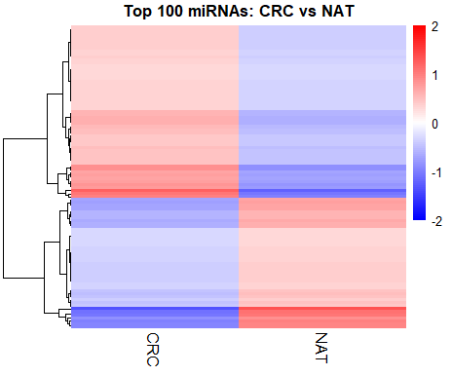
Figure 1: Heatmap showing the top 100 miRNAs expressed across CRC and NAT groups
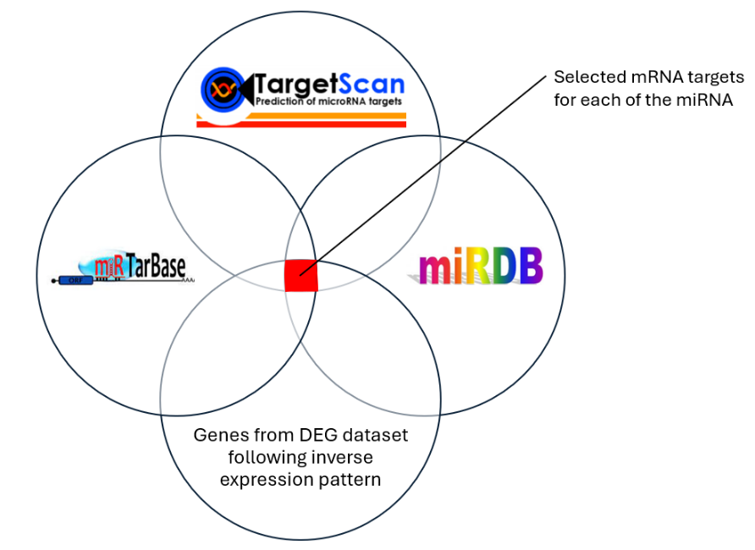
Aim 1b: Predicting the mRNA targets of CRC associated miRNAs using integrative prediction tools: The mRNA targets for each of the selected miRNAs were predicted using three widely used databases: miRDB, TargetScan, and miRTarBase, and were further filtered based on their expression in our DEG dataset. miRDB is a prediction tool that uses a machine learning model trained on high-throughput sequencing data to identify likely miRNA targets by assigning a score, with higher scores indicating stronger confidence¹². The results were filtered based on a score threshold of >70 and then compared with TargetScan predictions. TargetScan predicts the targets of miRNAs by searching for conserved sequences or looking for seed matches with the mRNA¹³. Thus, the overlapping mRNAs between these two tools were selected for further analysis using miRTarBase, which provides a collection of experimentally validated miRNA–target mRNA interactions from published literature¹⁴. From this set of matches, target mRNAs were selected based on their presence in our set of DEGs, following an inverse expression pattern with the miRNAs they target. Figure 2 illustrates the target prediction workflow. The predicted target mRNAs, along with the DEGs were matched such that, for each upregulated miRNA, downregulated genes were considered, and for downregulated miRNAs, only upregulated genes were selected. Table 1 shows a few of the most significant miRNA in each category and its corresponding mRNA target.
Figure 2: miRNA Target Prediction Workflow: Databases like miRDB, TargetScan, miRTarBase employed with our DEG dataset to find the significantly relevant mRNA targets of the miRNAs.

 | miRNAs | log2FC | Target mRNA | log2FC
Upregulated miRNA -> Downregulated target | miR-200a-3p | 3.189 | EPHA7 | -3.177
Downregulated miRNA  -> Upregulated target | miR-145-5p | -2.918 | MYCN | 2.017
Table 1: The significant miRNAs and their corresponding targets with each of their expression values (log2FC)
From this table, we can see that miR-200a-3p is predicted to target EPHA7 in its 3′-UTR, suggesting functional repression of that gene. Wang et al. (2005) found that silencing EPHA7 via promoter hypermethylation removes its tumor-suppressive ephrin signaling, thereby facilitating increased proliferation and invasiveness in colorectal cancer cells¹⁵. Similarly, the predicted tools indicated that miR-145-5p targets MYCN in its 3’-UTR, also suggesting functional repression. Esch et al. (2020) showed that MYCN overexpression drives cancer stem cell like traits and epithelial–mesenchymal transition, thereby boosting tumor proliferation, invasion, and therapy resistance¹⁶. These illustrate some of the identified targets. We will explore additional targets by adjusting the filter criteria to include more target mRNAs, if necessary.
C1.3. Potential pitfalls and alternative strategies: One primary challenge anticipated was obtaining sufficient CRC tissue samples, particularly from Hispanic patients. Due to underrepresentation in clinical studies and biobanks, Hispanic cohorts are often limited in both quantity and quality. This limitation poses a significant barrier to achieving robust statistical power when comparing molecular profiles between Hispanic and NHW groups. To address this, we plan to acquire additional commercially available CRC tissue samples to improve representation and strengthen statistical power for comparative analyses. Furthermore, different databases may use different gene identifiers, so we will carefully select the correct targets when integrating results from these sources. Additionally, these databases like miRBase, Ensembl etc. are frequently updated, so it is important to remain consistent with the version in our analysis.
C2. Specific Aim 2: To investigate the regulation of differentially expressed miRNAs in CRC among Hispanic (H-CRC) and Non-Hispanic White (NHW-CRC) patients
C2.1 Preliminary data: Colorectal cancer (CRC) remains a major health concern for the Hispanic population. They are more likely to be diagnosed at later stages of the disease compared to the NHW population. One significant contributing factor is reduced access to preventive care and early screening (e.g., colonoscopies) due to socioeconomic barriers, healthcare disparities, and cultural or language differences. As a result, many Hispanic patients are not diagnosed until late Stage IV, when CRC has already metastasized, drastically reducing treatment effectiveness and long-term survival rates. This late detection emphasizes a critical gap in current diagnostic strategies and the need for more accessible, non-invasive molecular screening tools.
C2.2 Research Approach: Aim 2a: Identifying the differentially expressed miRNAs between H-CRC and NHW-CRC samples: To pinpoint differentially regulated miRNAs in Hispanic colorectal cancer, we performed differential expression analyses for two comparisons: Hispanic CRC (H-CRC) vs Hispanic NAT (H-NAT), and Non-Hispanic White CRC (NHW-CRC) vs NHW NAT, using the DESeq2 pipeline established in Aim 1a. After filtering for genes and miRNAs (|log2FC| ≥ 2, p-adjusted ≤ 0.05), we identified 1785 genes dysregulated in H-CRC and 2641 genes dysregulated in NHW-CRC (relative to their respective NAT samples). Among these, 750 genes were differentially expressed exclusively in the Hispanic cohort (present in H-CRC but not in NHW-CRC), as shown by the Venn diagram in Figure 3. This ethnicity-specific subset yields a focused miRNA expression signature that may underlie the molecular disparities observed in Hispanic CRC patients, and it was further used for mRNA target prediction.
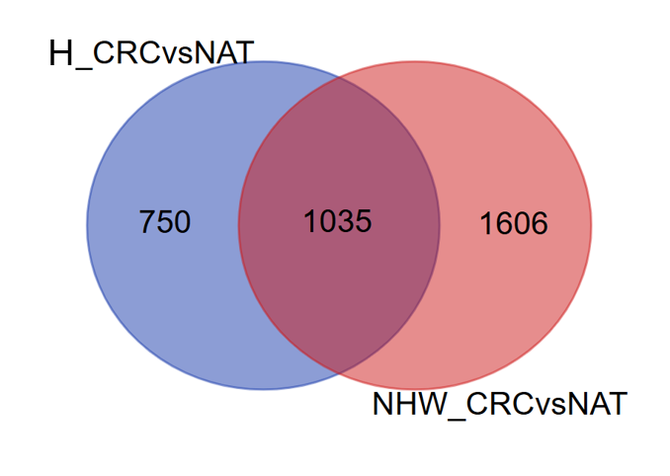
Figure 3: Venn diagram showing differentially expressed genes in Hispanic CRC vs NAT data and NHW CRC vs NAT, where 750 genes were unique in H_CRC
Aim 2b: Predicting the mRNA targets of differentially expressed miRNAs between H-CRC and NHW-CRC using integrative prediction tools: For each group-specific miRNA, target prediction was carried out using the same tools described in Aim 1b, supplemented by evidence from the literature. To ensure biological relevance, we refined the predicted interactions by filtering for inverse expression patterns between each miRNA and its putative targets using our DEG list. This process included pairing significantly upregulated miRNAs with target mRNAs showing significant downregulation, and vice versa. As an example, Table 2 shows a list of such miRNAs and their targeted mRNAs with their expression level.

 | miRNAs | log2FC | Target mRNA | log2FC
Upregulated miRNA -> Downregulated target | miR-200a-3p | 1.125 | OLFM1 | -2.228
Downregulated miRNA  -> Upregulated target | miR-149-3p | -3.418 | F2RL2 | 2.059
Table 2: The significant miRNAs and their corresponding targets with each of their expression values (log2FC) uniquely expressed in Hispanic CRC sample
From this table, we can see that miR-200a-3p targets the OLFM1 gene. This miRNA is upregulated in Hispanic CRC samples, thereby repressing its target gene as predicted. Shi et al. (2016) found that downregulation of OLFM1 can release its inhibition of NIK, hyperactivating non-canonical NF-κB signaling and promoting tumor growth, invasion, and metastasis¹⁷. Similarly, miR-149-3p is predicted to target F2RL2. Zhou et al. (2022) demonstrated that overexpression of F2RL2 in CRC drives tumor progression by hyperactivating protease-activated receptor signaling, enhancing cancer cell proliferation, migration, and invasion¹⁸. Similarly, we will examine additional miRNAs and their mRNA targets by adjusting the screening filter if necessary.
C2.3. Potential pitfalls and alternative strategies: The ethnicity-biased miRNAs were few in number and were mostly low in expression in our dataset. Therefore, applying the stringent log₂FC ≥ 2 threshold used in Aim 1had a risk of missing true positives. To retain biologically meaningful signals, we repeated the differential expression test with a relaxed log₂FC ≥ 1 cutoff. If very few mRNA targets fulfill our screening criteria, we will shift focus from individual genes to pathway-level enrichment and network analyses, using Qiagen’s Ingenuity Pathway Analysis (IPA)¹⁹ and meta-analysis of public datasets to identify shared functional modules.
C3. Specific Aim 3: To experimentally validate key miRNA-mRNA interactions with their specific targets and evaluating their role in the prognosis of CRC in cells
C3.1 Preliminary data: Our integrative bioinformatic analysis identified several candidate miRNA–mRNA pairs in colorectal cancer (CRC) that exhibit strong inverse expression patterns and are supported by experimental evidence in databases such as miRTarBase. Notably, some of these interactions have not yet been validated in CRC-specific cellular contexts. To prioritize interactions for experimental validation, we selected only those with the highest confidence scores from prediction tools that also overlap with our DEG list, and then develop appropriate in vitro models for downstream validation experiments.
C3.2 Research Approach: Aim 3a: Validating the effect of miRNA upregulation on target mRNA suppression: Colorectal cancer cell lines will be transfected with synthetic miRNA mimics to increase the intracellular levels of selected miRNAs identified in our analyses²⁰. After transfection, qRT-PCR will quantify the predicted target mRNAs to assess whether increased miRNA expression significantly downregulates the target transcript levels. Complementary Western blot analyses will confirm corresponding decreases in target protein levels, providing direct evidence of miRNA-mediated gene repression at both the transcript and protein levels. These experiments will also validate the specificity and efficiency of miRNA mimic transfections, clarifying how miRNA-driven target suppression contributes to the molecular pathology of CRC.
Aim 3b: Validating the effect of miRNA downregulation on target mRNA activation: To examine the consequences of reduced miRNA expression, CRC cells will be treated with specific miRNA inhibitors (antagomirs) to downregulate selected miRNAs²¹. After treatment, qRT-PCR and Western blotting will measure the target gene’s mRNA and protein levels, respectively, to determine if decreased miRNA expression results in increased expression of the target mRNAs. Observing an increased target mRNA expression following miRNA depletion will confirm the regulatory role of these miRNAs. Additionally, these experiments will mimic conditions seen in CRC tumors where certain miRNAs are naturally underexpressed, providing insight into how loss of specific miRNA function may drive CRC progression.
Aim 3c: Evaluating the impact of miRNA-mRNA mediated regulations on CRC cell proliferation: We will link molecular validation to biological outcomes by determining how the identified miRNA–mRNA interactions affect CRC cell proliferation (a hallmark of cancer progression). CRC cell lines will undergo miRNA modulation through mimic transfection or antagomir-mediated inhibition, and the resulting effects on cell growth will be assessed using CCK-8 proliferation assays. Rescue experiments will further confirm that the observed changes in proliferation are specifically due to the miRNA–mRNA interaction, achieved by restoring or suppressing the expression of target mRNAs alongside miRNA modulation. These experiments will clarify the mechanistic role of miRNA dysregulation in CRC cell growth, potentially informing prognosis and therapeutic strategies.
C3.3. Potential pitfalls and alternative strategies: Experimental modulation of miRNAs using mimics or antagomirs may encounter challenges such as inefficient transfection, which can lead to inadequate changes in miRNA levels and inconsistent effects on target gene expression or cellular phenotypes. To address this, we will optimize transfection protocols and consider alternative delivery methods like electroporation or viral vectors. We may also use an RNA sponge to bind and inactivate miRNAs²², thereby relieving the repression of their target mRNAs. If miRNA modulation shows no effect on cell growth, we will employ other functional assays (e.g., apoptosis and migration assays) to detect additional phenotypic effects.
E. Timeline: Specific Aims 1 and 2 will be revised using new datasets and are projected to be completed by the end of Fall 2025. Aim 3 will begin in Spring 2026 and is expected to be completed by Summer 2027. The following table 3 shows a visual timeline of the estimated project completion.
Aims | Sub Aims | Year 2025 |  | Year 2026 |  |  | Year 2027
Aims | Sub Aims | Summer | Fall | Spring | Summer | Fall | Spring | Summer | Fall
Aim 1 | Aim 1a | ✓ | ✓
Aim 1 | Aim 1b | ✓ | ✓
Aim 2 | Aim 2a | ✓ | ✓
Aim 2 | Aim 2b | ✓ | ✓
Aim 3 | Aim 3a |  |  | ✓ | ✓ | ✓ | ✓ | ✓
Aim 3 | Aim 3b |  |  | ✓ | ✓ | ✓ | ✓ | ✓
Aim 3 | Aim 3c |  |  | ✓ | ✓ | ✓ | ✓ | ✓
Manuscript |  |  |  |  |  |  | ✓ | ✓
Defense |  |  |  |  |  |  |  |  | ✓
Table 3: Timeline of the entire project

References:
1. Colorectal Cancer — Cancer Stat Facts. https://seer.cancer.gov/statfacts/html/colorect.html.
2. Chen, K., Collins, G., Wang, H. & Toh, J. W. T. Pathological Features and Prognostication in Colorectal Cancer. Current Oncology 2021, Vol. 28, Pages 5356-5383 28, 5356–5383 (2021).
3. Petrelli, F. et al. Prognostic survival associated with left-sided vs right-sided colon cancer a systematic review and meta-analysis. JAMA Oncol 3, 211–219 (2017).
4. Swan, J., Breen, N., Coates, R. J., Rimer, B. K. & Lee, N. C. Progress in cancer screening practices in the United States. Cancer 97, 1528–1540 (2003).
5. Stefanidis, D. et al. Colorectal cancer in Hispanics: A population at risk for earlier onset, advanced disease, and decreased survival. American Journal of Clinical Oncology: Cancer Clinical Trials 29, 123–126 (2006).
6. Acuna-Villaorduna, A. R., Lin, J., Kim, M. & Goel, S. Racial/ethnic disparities in early-onset colorectal cancer: implications for a racial/ethnic-specific screening strategy. Cancer Med 10, 2080–2087 (2021).
7. Miller, K. D. et al. Cancer statistics for the US Hispanic/Latino population, 2021. CA Cancer J Clin 71, 466–487 (2021).
8. Chen, L. et al. Trends in the development of miRNA bioinformatics tools. Brief Bioinform 20, 1836–1852 (2019).
9. Esquela-Kerscher, A. & Slack, F. J. Oncomirs — microRNAs with a role in cancer. Nature Reviews Cancer 2006 6:4 6, 259–269 (2006).
10. Zhan, C. et al. Identification of reference miRNAs in human tumors by TCGA miRNA-seq data. Biochem Biophys Res Commun 453, 375–378 (2014).
11. Love, M. I., Huber, W. & Anders, S. Moderated estimation of fold change and dispersion for RNA-seq data with DESeq2. Genome Biol 15, 1–21 (2014).
12. Chen, Y. & Wang, X. miRDB: an online database for prediction of functional microRNA targets. Nucleic Acids Res 48, D127–D131 (2020).
13. Agarwal, V., Bell, G. W., Nam, J. W. & Bartel, D. P. Predicting effective microRNA target sites in mammalian mRNAs. Elife 4, e05005 (2015).
14. Hsu, S. Da et al. miRTarBase: a database curates experimentally validated microRNA–target interactions. Nucleic Acids Res 39, D163–D169 (2011).
15. Wang, J. et al. Downregulation of EphA7 by hypermethylation in colorectal cancer. Oncogene 24, 5637–5647 (2005).
16. Esch, J. S. A. et al. Isolation and Characterization of Two Novel Colorectal Cancer Cell Lines, Containing a Subpopulation with Potential Stem-Like Properties: Treatment Options by MYC/NMYC Inhibition. Cancers 2020, Vol. 12, Page 2582 12, 2582 (2020).
17. Shi, W. et al. Olfactomedin 1 negatively regulates NF-κB signalling and suppresses the growth and metastasis of colorectal cancer cells. J Pathol 240, 352–365 (2016).
18. Zhou, R., Gao, Z. & Ju, Y. Novel six-gene prognostic signature based on colon adenocarcinoma immune-related genes. BMC Bioinformatics 23, 1–20 (2022).
19. Bioinformatics Software | QIAGEN Digital Insights. https://digitalinsights.qiagen.com/.
20. Wang, Z. The guideline of the design and validation of MiRNA mimics. Methods Mol Biol 676, 211–223 (2011).
21. Preethi, K. A., Lakshmanan, G. & Sekar, D. Antagomir technology in the treatment of different types of cancer. Epigenomics 13, 481–484 (2021).
22. Bak, R. O. & Mikkelsen, J. G. miRNA sponges: Soaking up miRNAs for regulation of gene expression. Wiley Interdiscip Rev RNA 5, 317–333 (2014).

